**All Selector (“*”)**

**<!doctype html>**

<html lang="en">

<head>

<meta charset="utf-8">

<title>all demo</title>

<style>

h3 {

margin: 0;

}

div, span, p {

width: 80px;

height: 40px;

float: left;

padding: 10px;

margin: 10px;

background-color: #EEEEEE;

}

</style>

<script src="https://code.jquery.com/jquery-1.10.2.js"></script>

</head>

<body>

<div>DIV</div>

<span>SPAN</span>

<p>P <button>Button</button></p>

<script>

**var** elementCount = $( "*" ).css( "border", "3px solid red" ).length;

$( "body" ).prepend( "<h3>" + elementCount + " elements found</h3>" );

</script>

</body>

</html>

#### Demo:

**<!doctype html>**

<html lang="en">

<head>

<meta charset="utf-8">

<title>all demo</title>

<style>

h3 {

margin: 0;

}

div, span, p {

width: 80px;

height: 40px;

float: left;

padding: 10px;

margin: 10px;

background-color: #EEEEEE;

}

**#test** {

width: auto;

height: auto;

background-color: transparent;

}

</style>

<script src="https://code.jquery.com/jquery-1.10.2.js"></script>

</head>

<body>

<div id="test">

<div>DIV</div>

<span>SPAN</span>

<p>P <button>Button</button></p>

</div>

<script>

**var** elementCount = $( "#test" ).find( "*" ).css( "border", "3px solid red" ).length;

$( "body" ).prepend( "<h3>" + elementCount + " elements found</h3>" );

</script>

</body>

</html>

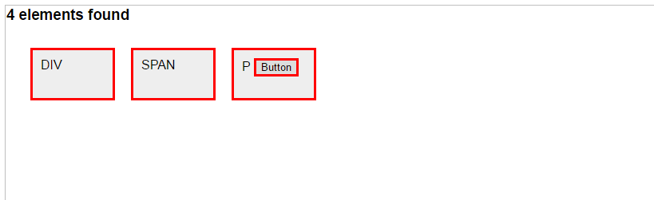

# Class Selector (“.class”)

# Finds the element with the class "myClass".

**<!doctype html>**

<html lang="en">

<head>

<meta charset="utf-8">

<title>class demo</title>

<style>

div, span {

width: 120px;

height: 40px;

float: left;

padding: 10px;

margin: 10px;

background-color: #EEEEEE;

}

</style>

<script src="https://code.jquery.com/jquery-1.10.2.js"></script>

</head>

<body>

<div class="notMe">div class="notMe"</div>

<div class="myClass">div class="myClass"</div>

<span class="myClass">span class="myClass"</span>

<script>

$( ".myClass" ).css( "border", "3px solid red" );

</script>

</body>

</html>

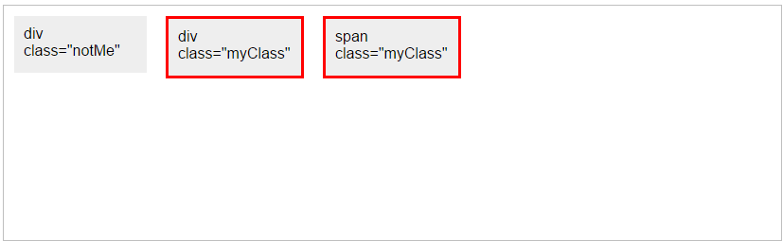

E2-

Finds the element with both "myclass" and "otherclass" classes.

**<!doctype html>**

<html lang="en">

<head>

<meta charset="utf-8">

<title>class demo</title>

<style>

div, span {

width: 120px;

height: 40px;

float: left;

padding: 10px;

margin: 10px;

background-color: #EEEEEE;

}

</style>

<script src="https://code.jquery.com/jquery-1.10.2.js"></script>

</head>

<body>

<div class="myclass">div class="notMe"</div>

<div class="myclass otherclass">div class="myClass"</div>

<span class="myclass otherclass">span class="myClass"</span>

<script>

$( ".myclass.otherclass" ).css( "border", "13px solid red" );

</script>

</body>

</html>

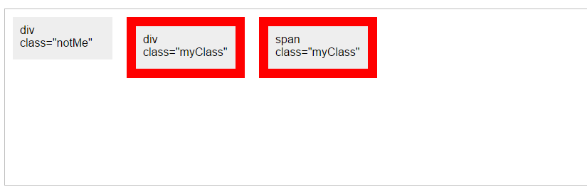

# Element Selector (“element”)

*Selects all elements with the given tag name.*

Finds every DIV element.

**<!doctype html>**

<html lang="en">

<head>

<meta charset="utf-8">

<title>element demo</title>

<style>

div, span {

width: 60px;

height: 60px;

float: left;

padding: 10px;

margin: 10px;

background-color: #eee;

}

</style>

<script src="https://code.jquery.com/jquery-1.10.2.js"></script>

</head>

<body>

<div>DIV1</div>

<div>DIV2</div>

<span>SPAN</span>

<script>

$( "div" ).css( "border", "9px solid red" );

</script>

</body>

</html>

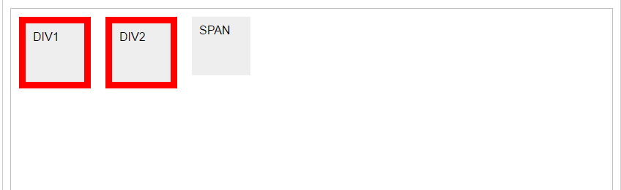

# ID Selector (“#id”)

*Selects a single element with the given id attribute.*

Select the element with the id "myDiv" and give it a red border.

**<!doctype html>**

<html lang="en">

<head>

<meta charset="utf-8">

<title>id demo</title>

<style>

div {

width: 90px;

height: 90px;

float: left;

padding: 5px;

margin: 5px;

background-color: #eee;

}

</style>

<script src="https://code.jquery.com/jquery-1.10.2.js"></script>

</head>

<body>

<div id="notMe"><p>id="notMe"</p></div>

<div id="myDiv">id="myDiv"</div>

<script>

$( "#myDiv" ).css( "border", "3px solid red" );

</script>

</body>

</html>

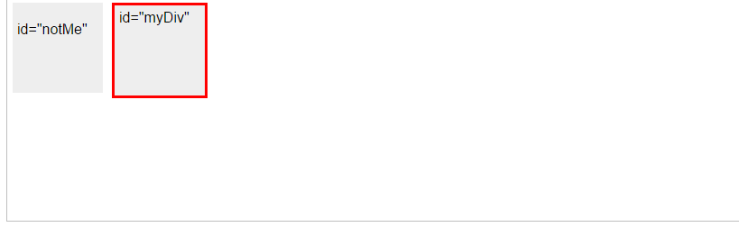

Select the element with the id "myID.entry[1]" and give it a red border.

Note how certain characters must be escaped with backslashes.

**<!doctype html>**

<html lang="en">

<head>

<meta charset="utf-8">

<title>id demo</title>

<style>

div {

width: 300px;

float: left;

padding: 2px;

margin: 3px;

background-color: #eee;

}

</style>

<script src="https://code.jquery.com/jquery-1.10.2.js"></script>

</head>

<body>

<div id="myID.entry[0]">id="myID.entry[0]"</div>

<div id="myID.entry[1]">id="myID.entry[1]"</div>

<div id="myID.entry[2]">id="myID.entry[2]"</div>

<script>

$( "#myID\\.entry\\[1\\]" ).css( "border", "3px solid red" );

</script>

</body>

</html>

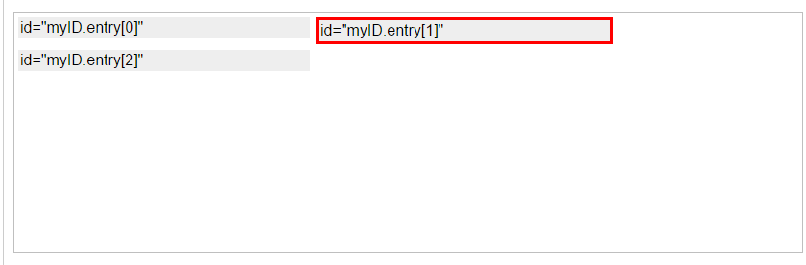

# Multiple Selector (“selector1, selector2, selectorN”)

*elects the combined results of all the specified selectors.*

Finds the elements that match any of these three selectors.

**<!doctype html>**

<html lang="en">

<head>

<meta charset="utf-8">

<title>multiple demo</title>

<style>

div, span, p {

width: 126px;

height: 60px;

float: left;

padding: 3px;

margin: 2px;

background-color: #eee;

font-size: 14px;

}

</style>

<script src="https://code.jquery.com/jquery-1.10.2.js"></script>

</head>

<body>

<div>div</div>

<p class="myClass">p class="myClass"</p>

<p class="notMyClass">p class="notMyClass"</p>

<span>span</span>

<script>

$( "div, span, p.myClass" ).css( "border", "3px solid red" );

</script>

</body>

</html>

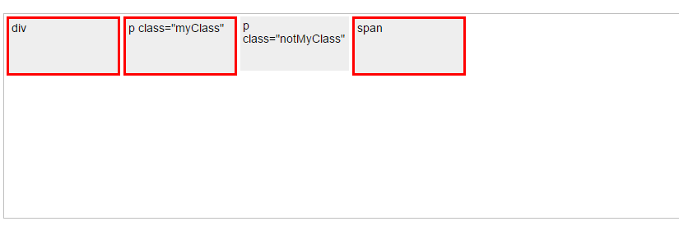

Show the order in the jQuery object.

**<!doctype html>**

<html lang="en">

<head>

<meta charset="utf-8">

<title>multiple demo</title>

<style>

b {

color: red;

font-size: 16px;

display: block;

clear:left;

}

div, span, p {

width: 40px;

height: 40px;

float: left;

margin: 10px;

background-color: blue;

padding: 3px;

color: white;

}

</style>

<script src="https://code.jquery.com/jquery-1.10.2.js"></script>

</head>

<body>

<span>span</span>

<p>p</p>

<p>p</p>

<div>div</div>

<span>span</span>

<p>p</p>

<div>div</div>

<b></b>

<script>

**var** list = $( "div, p, span" )

.map( **function**() {

**return** **this**.tagName;

})

.get()

.join( ", " );

$( "b" ).append( document.createTextNode( list ) );

</script>

</body>

</html>

